- Given a list of delivery timestamps as strings (e.g., ['2024-06-01 14:30', '2024-06-02 09:15', '2024-06-03 20:45']), use pandas and pd.to_datetime() to convert them into datetime objects and print the result.
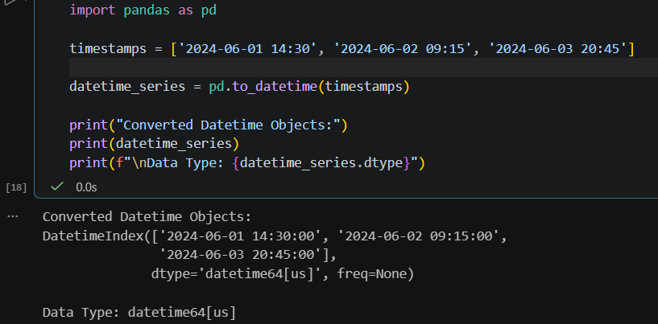

- Load a CSV file containing order dates from a Flipkart-style order history (column: 'order_date', format: 'YYYY-MM-DD HH:MM:SS'). Extract the year, month, and weekday for each order and add them as new columns in the DataFrame.
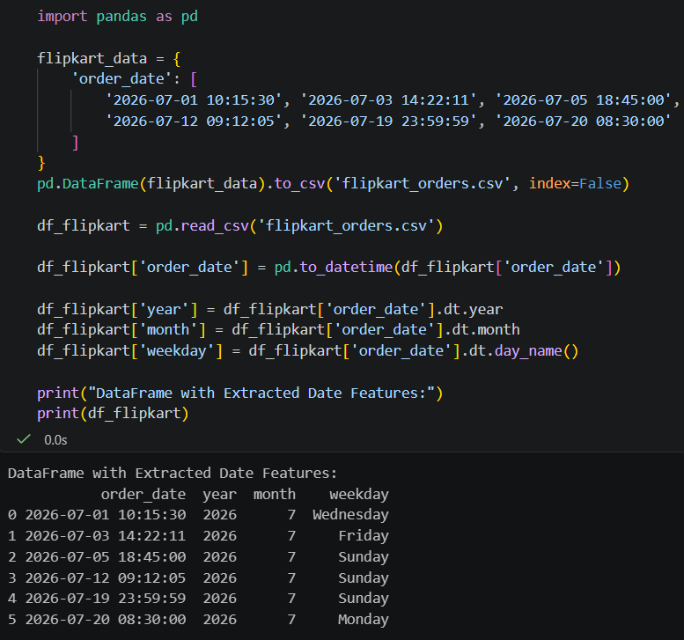

- Set the 'order_date' column as the index of your DataFrame and use resampling to calculate the total number of orders placed each week. Use df.resample('W').size() after setting the datetime index.
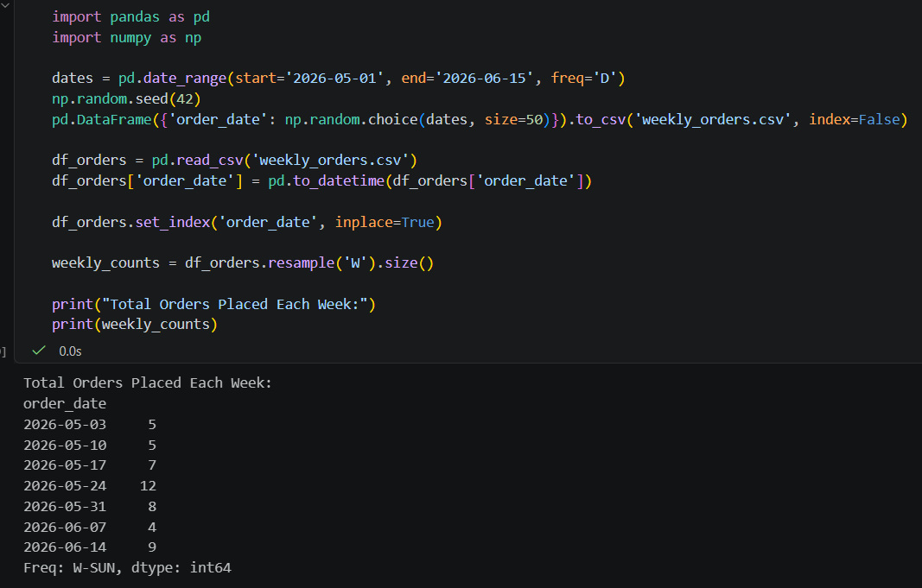

- Suppose you have a DataFrame of Instagram posts with a 'posted_at' column in UTC. Convert these timestamps to 'Asia/Kolkata' timezone and display the first 5 converted times.
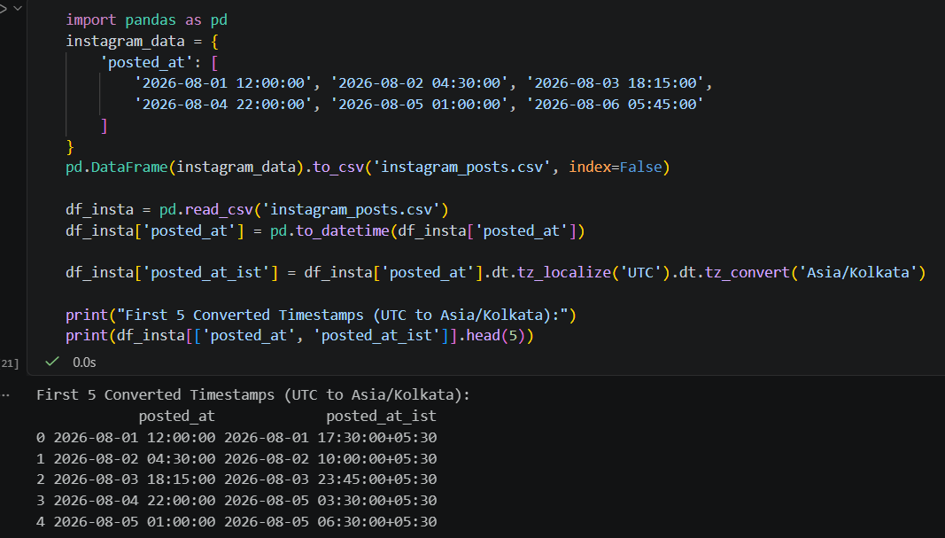

- Create a new feature called 'is_weekend' in your DataFrame that marks True if an order was placed on Saturday or Sunday, and False otherwise. Do not use any external libraries except pandas and numpy.
